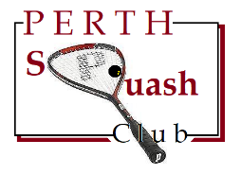
Perth Squash Club
2020 Club Championships

Enter now for this year’s Club Championships!
>>>>
Simply drop an e-mail or text to Hugh Alexander (details below) or speak to any Committee Member.
>>>>
Courts will be provided for Finals Night, on Wednesday, 1st April, and will also be available for Semi Finals on Monday, 30th March.
Otherwise, make your own arrangements with your opponent for the earlier rounds.
>>>>
There will also be a Plate competition for first round losers.
>>>>
The draw for first round matches will be made next Monday (at Club Night) so
ACT NOW! and get your entry in.
>>>>
Entry is free and all club members are cordially invited to take part.
To enter: e-mail chairman@perthsquashclub.co.uk or text 07802 885449 or speak to any Committee Member. Good luck!
CLOSE THIS FILE TO RETURN TO WEB PAGE

